Swiss Franc Shock and Exchange Rate Analysis
Author: Eshan Mukherjee

Country, Currency Pair, and Shock
Country: Switzerland.
Currency pair: EUR/CHF (Swiss francs per euro).
Shock: On 15 January 2015, the Swiss National Bank (SNB) unexpectedly abandoned its minimum exchange rate policy of CHF 1.20 per euro, which had been in place since September 2011. This triggered the largest single-day move in a G10 currency pair in modern history.
The EUR/CHF rate had been artificially stable at or just above 1.20 for over three years. Within minutes of the announcement, EUR/CHF collapsed from 1.2010 to an intraday low between 0.8500 and 0.9650 depending on venue, a roughly 20-30% intraday decline.
By the close on 15 January, EUR/CHF settled near 0.9650, a close-to-close drop of approximately 19.7%. The Swiss Market Index (SMI) fell over 10%, and several retail FX brokers including Alpari UK became insolvent due to the extreme price gap (European Parliamentary Research Service [EPRS], 2015; FXCM, 2015).

Exchange Rate Data and Price Movements
Figure 1 plots the EUR/CHF spot rate from October 2014 through June 2015. The flat line at 1.20 before January 15 reflects the SNB floor; the vertical drop is the shock; and the partial recovery to 1.04-1.07 illustrates the market finding a new equilibrium.
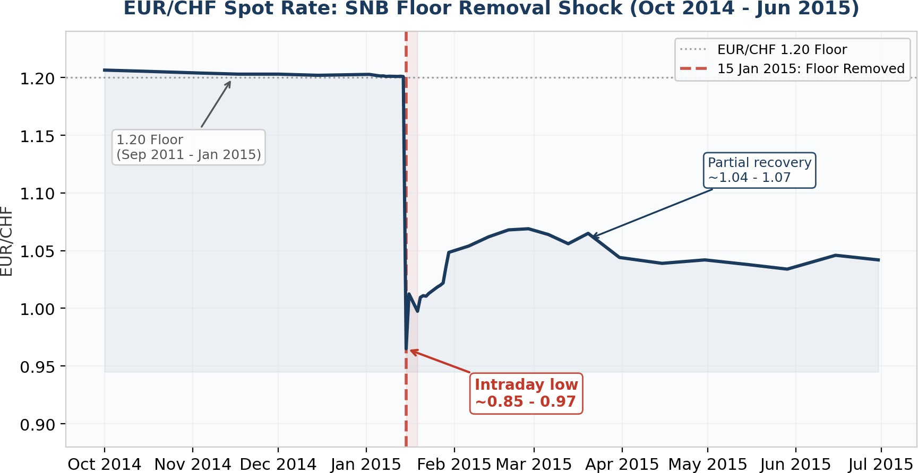
Figure 1: EUR/CHF spot rate, Oct 2014 - Jun 2015. Red dashed line marks the floor removal.
Figure 2 overlays daily percentage changes (bars) with cumulative change from a 12 January baseline (line). The -19.7% bar on January 15 dwarfs every other move. By end-March, EUR/CHF remained approximately 13% below pre-shock levels, indicating the repricing was mostly
permanent.
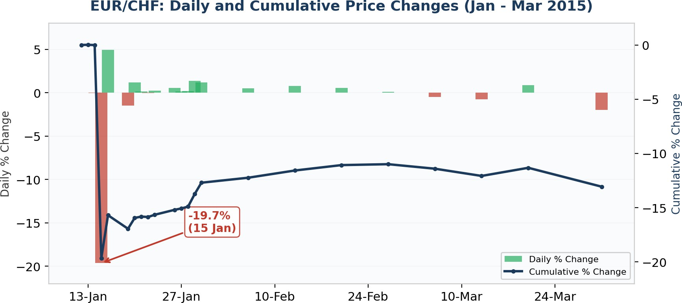
Figure 2: Daily % change (bars) and cumulative % change from baseline (line). Formula: Daily % = (Spot_t / Spot_t-1 - 1) x 100.
Table 1: Selected EUR/CHF Observations
Date | EUR/CHF | Daily % | Cumul. %
12-Jan-2015 | 1.2010 | 0.00% | 0.00%
14-Jan-2015 | 1.2009 | -0.02% | -0.01%
15-Jan-2015 | 0.9650* | -19.65% | -19.64%
16-Jan-2015 | 1.0125 | +4.92% | -15.69%
30-Jan-2015 | 1.0485 | +3.50% | -12.70%
27-Feb-2015 | 1.0690 | +0.19% | -10.99%
31-Mar-2015 | 1.0441 | -0.14% | -13.06%

* Intraday prints as low as 0.8500 on some venues; close shown. Cumul. % from 12-Jan baseline (1.2010).

Underlying Levers and Forces
Imminent ECB quantitative easing. The primary catalyst was the expectation that the ECB would soon launch large-scale bond purchases (announced 22 January). This would have weakened the euro dramatically, forcing the SNB to buy ever-larger quantities of euros to defend the floor. SNB Board member Fritz Zurbrugg later stated that maintaining the floor would have required intervention of approximately CHF 100 billion in January alone (Bank for International Settlements [BIS], 2017).
Safe-haven demand. The Swiss franc is a primary safe-haven currency. In January 2015, risk events converged: Greek elections on January 25 raised Grexit fears, Russian rouble instability persisted, and oil prices were falling. Each risk-off impulse increased global demand for CHF (EPRS, 2015).
Carry-trade unwind and liquidity vacuum. The floor had encouraged massive leveraged long EUR/CHF positions. When removed, forced liquidation created self-reinforcing cascades:
stop-losses triggered selling, which triggered more stops. FXCM reported bid-ask spreads exceeding 2,000-3,000 pips and liquidity providers withdrawing for ~40 minutes, transforming a
fundamental repricing into a 30%+ intraday overshoot (FXCM, 2015).
Interest rate differentials. The ECB deposit rate was -0.20% while the SNB range was 0% to
-0.25%, making CHF carry costs nearly zero and encouraging speculative inflows. ECB QE expectations were pushing euro-area real rates even lower, widening the real-rate gap favoring CHF (Swiss National Bank [SNB], 2015a).

Role of the Swiss National Bank
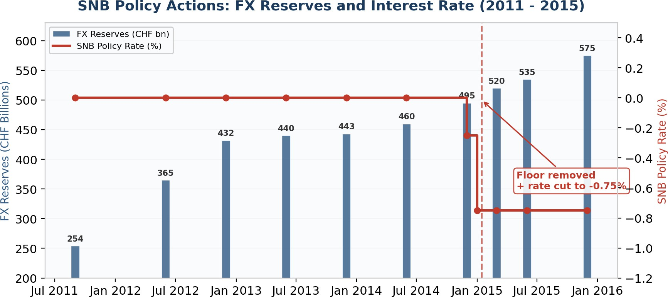
Figure 3: SNB FX reserves (bars) grew from CHF 254 bn to CHF 495 bn defending the floor. Policy rate (red line) cut to
-0.75% on the day of removal.
Before: The SNB introduced the 1.20 floor on 6 September 2011, pledging to buy foreign currency in unlimited quantities. Over three years, FX reserves expanded from CHF 254 billion to CHF 495 billion (~80% of GDP). On 18 December 2014, the SNB introduced a -0.25% rate on sight deposits. Vice-Chairman Danthine stated on 12 January 2015 that the floor remained the cornerstone of policy, just three days before removal (BIS, 2017).
During: On 15 January, the SNB simultaneously removed the floor and cut rates by 50 bps to
-0.75% (Libor target: -1.25% to -0.25%). Chairman Jordan stated the decision reflected the floor's unsustainability, not panic (SNB, 2015b).
After: The SNB adopted a dual-pillar approach: negative rates plus discretionary FX intervention. The negative rate restored the traditional interest rate differential with the eurozone, making CHF deposits costlier. Reserves continued rising after January, indicating ongoing intervention (SNB, 2015c).
Assessment: The SNB directly caused the shock. It also amplified it indirectly because three years of artificial stability encouraged massive leveraged positioning. The sudden removal, rather than gradual widening, maximized disruption. However, the objective was rational: preserving balance-sheet sustainability as reserve accumulation approached unsustainable levels.

Supply and Demand Analysis
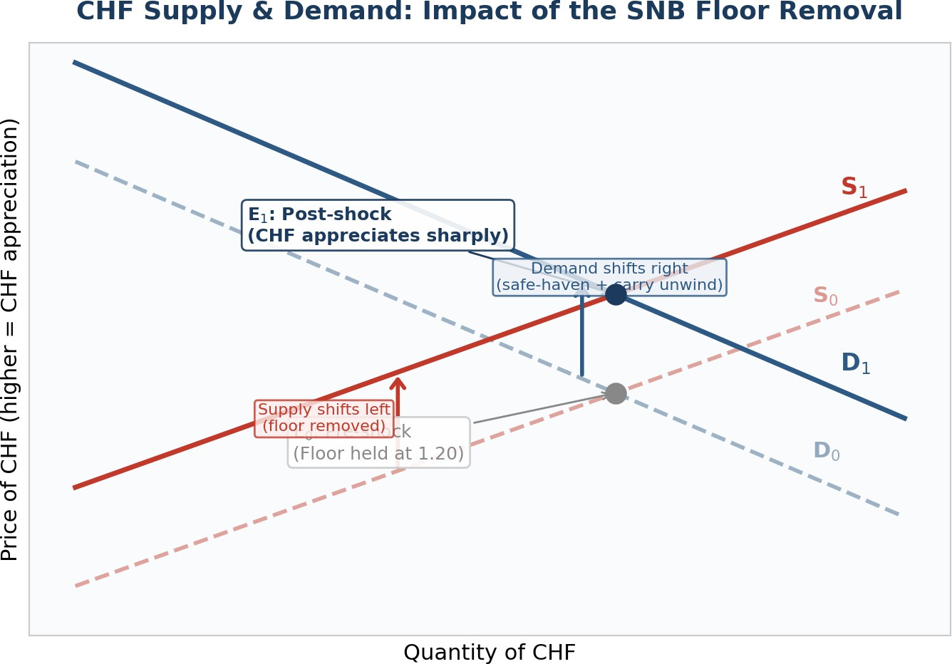
Figure 4: Conceptual supply-demand for CHF. Floor removal shifted supply left (S0 to S1); safe-haven and carry-unwind flows shifted demand right (D0 to D1). New equilibrium E1 reflects sharply higher CHF price.
Demand for CHF shifted right for three reasons: (1) safe-haven flows driven by Greek election uncertainty, Russian instability, and falling oil prices increased demand for Swiss franc assets; (2) forced unwinding of leveraged short-CHF carry trades required large CHF purchases; and (3) Swiss institutional repatriation of foreign-currency assets. The carry unwind was temporary (exhausting itself within days), while safe-haven demand was more persistent.
Supply of CHF shifted left because the floor removal eliminated the SNB's unlimited commitment to sell CHF and buy EUR. This was the dominant shift and a permanent regime change. The SNB had been the single largest CHF supplier to the FX market. The simultaneous rate cut to -0.75% partially offset this by making CHF deposits more expensive (a small rightward supply shift), but was far insufficient to counterbalance.
The net effect: a large rightward demand shift plus a sharp leftward supply shift produced violent CHF appreciation. Temporary components (panic, stop-losses) explain the intraday overshoot to 0.85-0.97. Persistent components (regime change, safe-haven preference) explain why EUR/CHF stabilized near 1.04-1.07 rather than returning to 1.20.

Policy Options, Long-Run Consequences, and Outlook
Policy tools and constraints. The SNB can cut rates deeper into negative territory, intervene in FX markets, or use forward guidance. But political resistance limits negative rates (a November 2014 gold referendum illustrated public sensitivity to balance-sheet risks); reserves at 80%+ of GDP strain credibility; and the SNB cannot control ECB policy, the primary external EUR/CHF driver (Danthine, 2017).
Long-run consequences. Swiss exporters absorbed the shock through margin compression and quality upgrading; aggregate exports proved surprisingly resilient. Retail import prices fell only
~3% two quarters later, as retailers absorbed much of the currency movement (CEPR, 2025). The SNB's balance sheet continued expanding to ~CHF 670 billion in reserves by end-2023. The
institution recorded a CHF 23 billion loss in 2015 and a record CHF 132 billion loss in 2022 from valuation effects (International Monetary Fund [IMF], 2023).
Has the trend reversed? Partially. EUR/CHF recovered to 1.05-1.10 through 2015-2017 and briefly approached 1.20 in late 2017 as ECB tightening expectations grew. However, renewed safe-haven demand during COVID-19 (2020) and the Russia-Ukraine conflict (2022) pushed EUR/CHF below parity. As of early 2026, it trades near 0.93-0.96, with the SNB policy rate at 0% and inflation near zero.

Two-Quarter Outlook (Q2-Q3 2026)
Base case: EUR/CHF trades in a 0.92-0.97 range, biased lower if global risk aversion persists from ongoing trade tensions. The SNB will likely rely on discretionary FX intervention rather than rate cuts.
- Downside risk (stronger CHF): U.S. tariff escalation or a European recession could push EUR/CHF below 0.90. A return to negative SNB rates would signal severe stress.
- Upside risk (weaker CHF): Trade tension de-escalation or hawkish ECB policy relative to the SNB could push EUR/CHF toward 1.00.
- Key monitors: SNB quarterly assessments (Mar/Jun 2026), Swiss CPI, EUR/CHF implied volatility, ECB rate decisions, and SNB sight-deposit data (intervention proxy).

