International Price Parity and Exchange Rates
Author: Eshan Mukherjee
The Law of One Price (LOOP) indicates that, ceteris paribus, the price of a good should be the same across markets (given transaction costs). For example, consider the price of T-shirts on Bourbon Street in New Orleans (or the price of a Hurricane drink on Bourbon Street).
If we believe that the LOOP should hold, then we should see the price of a good equalize across markets (including across countries). Prices should be equal (or near equal) even between countries - particularly countries that are physically close and have low costs of traversing borders (think Germany and Austria or Austria and Italy) or even England and France. Because these countries might not share a common currency, the exchange rate between the two countries should move such that prices of the same product is equal across markets.

The Big Mac Index
The Big Mac sandwich from McDonalds is a product that should (hypothetically) be priced equally across borders. Because the price of Big Mac is readily available across countries (published by the McDonalds corporation) and exchange rates between countries are readily available, we can test the LOOP across countries and across time.
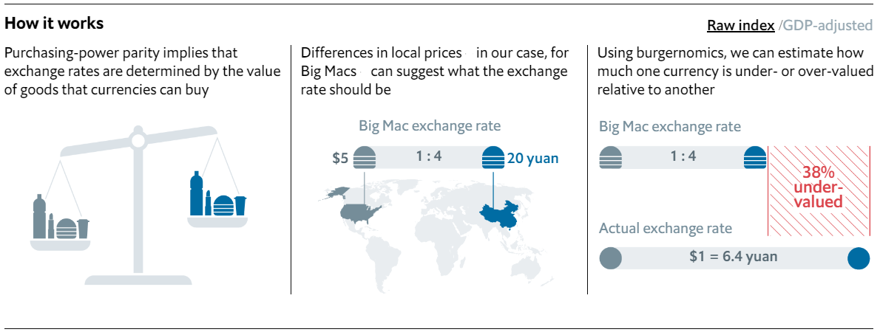
$$\frac{Country Specific {Price}_{it} Big Mac }{Dollar {Price}_{\$t} Big Mac}=e(\frac{{Currency}_{i}}{1\$})$$
If the left-hand side of the equation is greater than the right-hand side of the equation, then the country specific currency is over-valued (according to the exchange rate), and will have to depreciate going forward. If the left-hand side of the equation is less than the right-hand side of the equation, then the country specific currency is under-valued (according to the exchange rate), and will have to appreciate going forward.
For example, the Australian price of a Big Mac in December, 2023 was $7.70 AU, and the US dollar price of a Big Mac in December , 2023 was $5.69
$$\frac{7.70AU}{\$5.69}=1.3532\frac{AU}{\$}<[Actual]\frac{1.4929 AU}{1\$}$$
$$\frac{(1.4929-1.3532)}{1.4929}= .09357 or the AU is 9.3576\% Undervalued$$

GDP adjusted
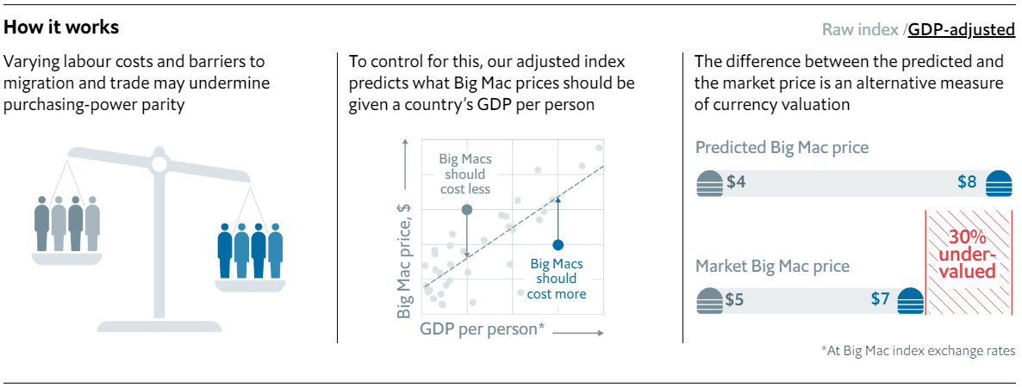
Economic Publication also created a GPD-adjusted index. For this index, the country specific price is translated into dollars (or some other currency such as the Euro, Yen, RMB, or Pound) using the current exchange rates. A regression is created using the Dollar (or Euro, Yen, RMB, Pound) GDP per person. Data points falling below the regression line should indicate that, ceteris paribus, prices of the Big Mac will rise in the future, while prices falling above the regression line should indicate that prices will fall in the future. These future price movement should indicate that either a) country specific prices will increase or decrease, or b) future exchange rates will change to increase or decrease the dollar price of the Big Mac in a specific country.
We can re-create some of this analysis using the Big Mac Index data on the Canvas site. (see the Canvas site)

The iPod Mini Index
Some have argued that the Big Mac is not mobile enough to really test the LOOP hypothesis. Economist from Counsil on Foreign Relations modified the Big Mac index and created the iPod Mini index (see here: ).
They found that the over-under on the exchange rates was much less dramatic when using the prices of iPod minis.
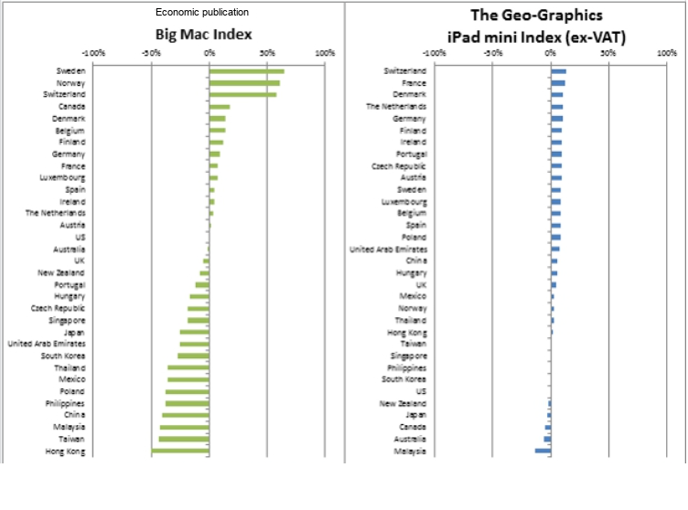
I’ve downloaded the prices of the iPad mini from 2021 and they are also listed in the Canvas site.
QUESTIONS/DELIVERABLES
- Replicate the Big Mac Index for 2025
- Replicate the GDP adjusted Index for 2023?
- Create the iPad mini index for 2021 (July) ?
- Create an air pod 2 index or an iPhone 16 index for 2023 (or most recent data: Technology Companypricecompare.com/airpods/2)
Data:
See canvas site & also…

Technology Companypricecompare.com/airpods/2

