Martingale Roulette Monte Carlo Analysis
Author: Eshan Mukherjee
Monte Carlo simulation summary for the four required scenarios

Model assumptions and stopping rules
- Even-money bet on American roulette: P(win)=18/38, P(lose)=20/38.
- Martingale: start wager=1; after loss, double next wager; after win, net +1 chip for that cycle and reset wager to 1.
- Episode stops immediately when profit reaches +M (final bankroll N+M) OR when the required next wager exceeds current bankroll (bust).
- Expected profit is defined as E [final bankroll - N].

Simulation settings used for these figures
- Monte Carlo estimates with fixed random seeds (reproducible). Scenarios 1 & 3: 120,000 episodes per figure.
- Scenarios 2 & 4: 150,000 episodes per figure.

Results: Probability of winning the episode

Scenario 1 (M=80): P(win episode) vs starting bankroll N (1..1000)
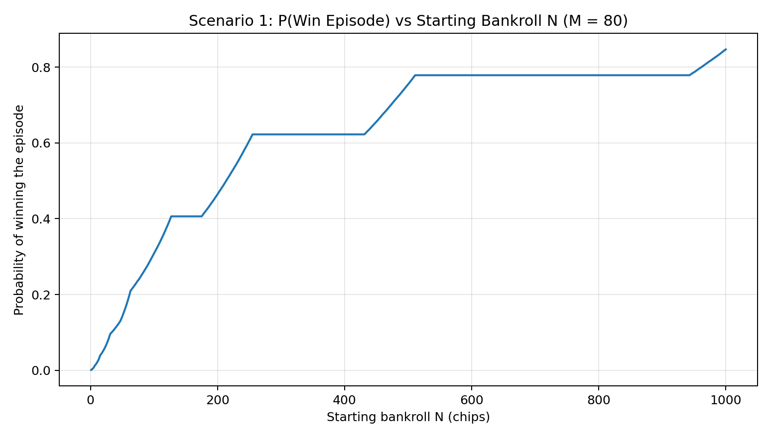
- Winning probability rises with starting bankroll N but in plateaus.
- Each step reflects whether the bankroll can survive deeper doubling levels during rare loss streaks.
- Even for large N, extremely long loss streaks can still force a bust before reaching +80.

Scenario 2 (N=256): P(win episode) vs target profit M (1..1000)
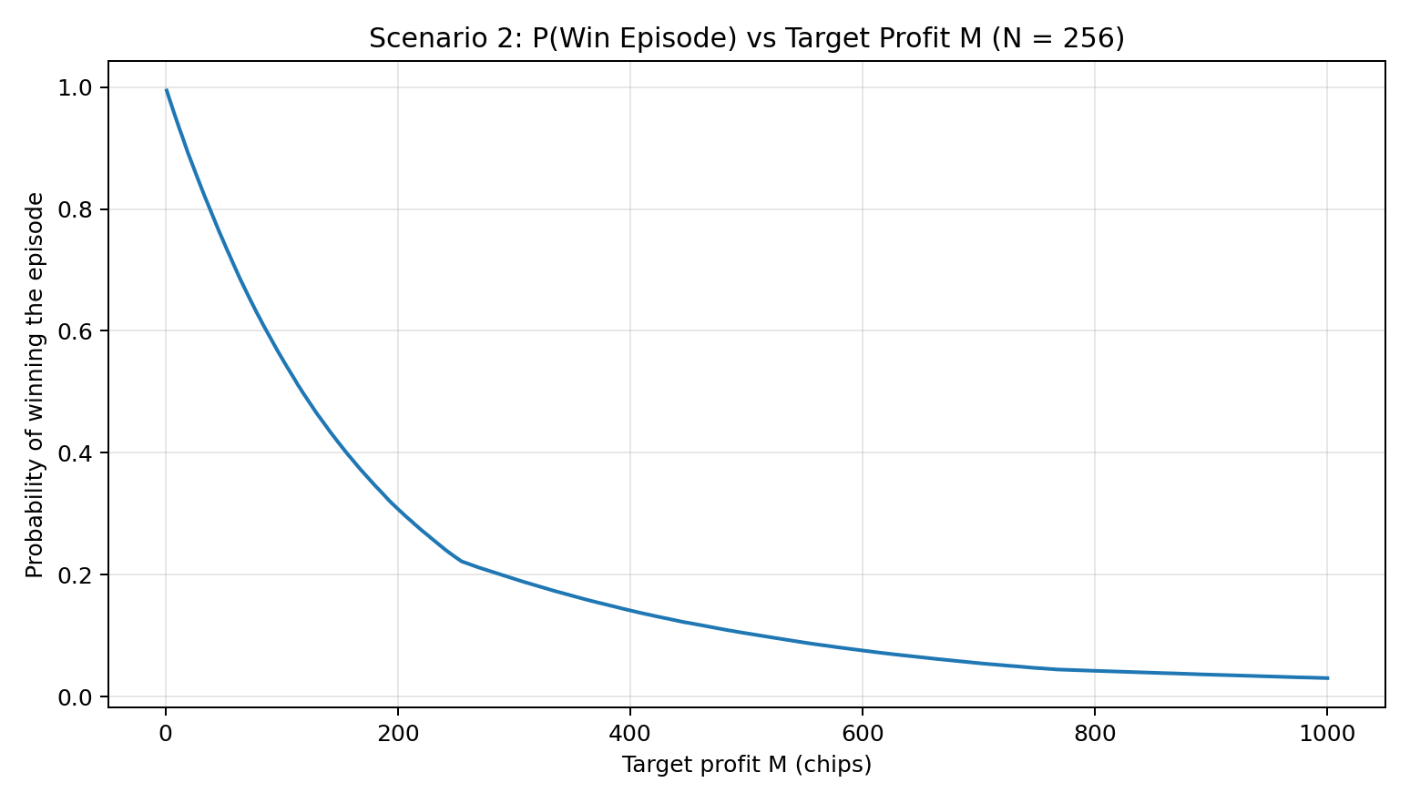
- As target profit M increases, the strategy must survive more cycles to finish.
- More cycles mean more chances to encounter a catastrophic loss streak that exceeds the bankroll.
- Therefore P(win) declines steadily as M grows.

Results: Expected profit (final bankroll minus starting bankroll)

Scenario 3 (M=80): Expected profit E[final bankroll - N] vs N (1..1000)
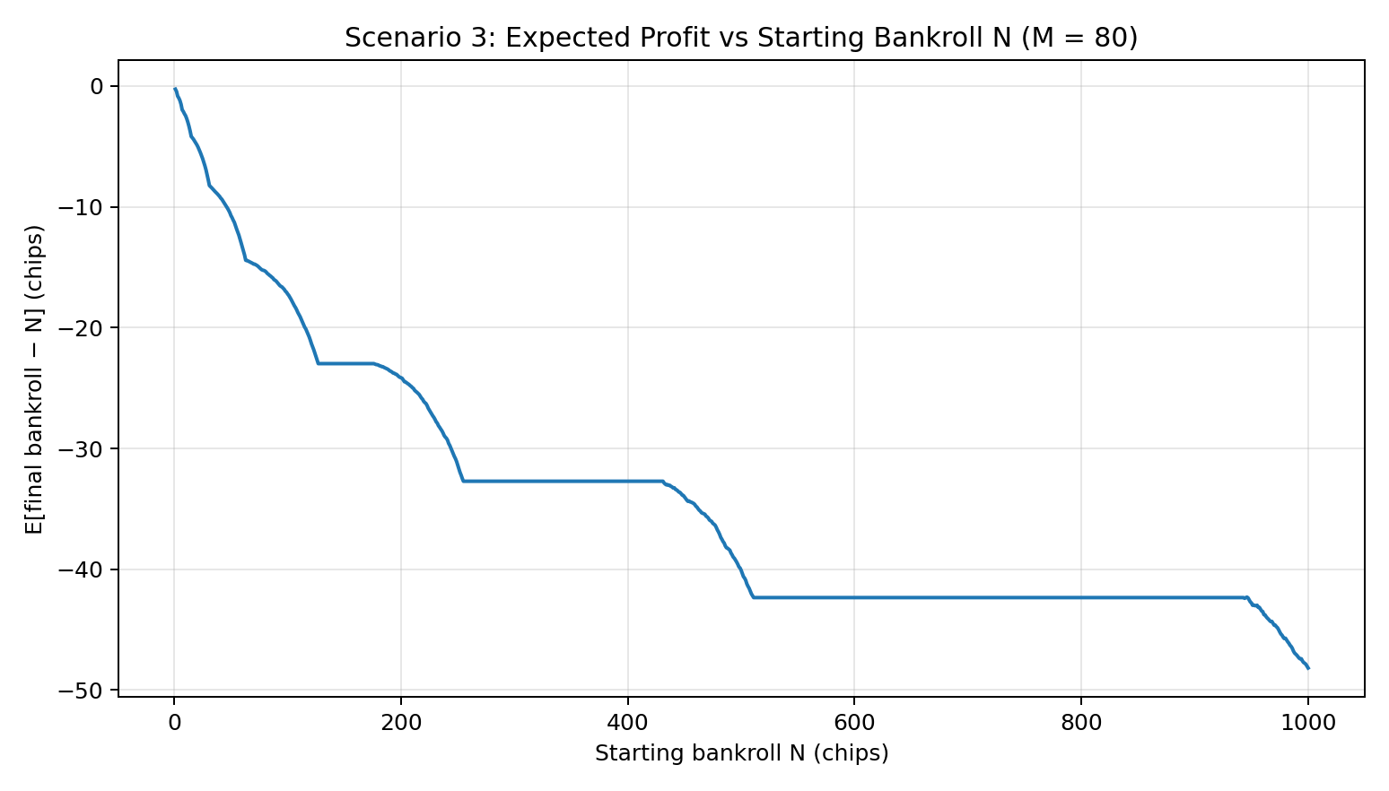
- Expected profit is negative over essentially the full N range because the house edge remains.
- Larger bankrolls reduce bust frequency but also allow the strategy to reach deeper (larger) doubling ladders.
- Those rare but large bust losses dominate the expectation.

Scenario 4 (N=256): Expected profit E[final bankroll - N] vs M (1..1000)
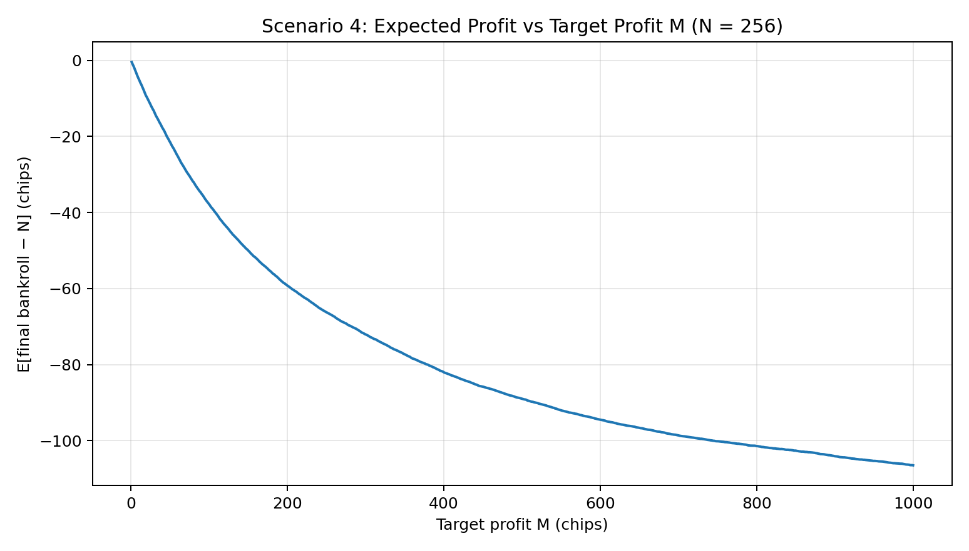
- With N fixed, increasing M makes the episode longer and increases exposure to rare loss streaks.
- The chance of eventually busting grows, while wins only lock in +M.
- Expected profit becomes more negative as M increases.

